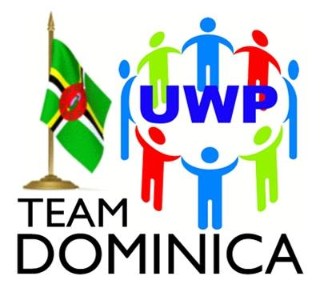
UNITED WORKERS PARTY
6 River Street, Roseau, Commonwealth of Dominica
Tel: (1) 767-265-0928 | (1) 767-3173-3014
uwpdaoffice@gmail.comwww.uwpteamdominica.com
President: Isaac Baptiste; Political Leader: Lennox Linton

Wednesday 18th August, 2021

PRESS RELEASE

UWP EXTENDS CONDOLENCES
TO
THE FAMILY, FRIENDS & ASSOCIATES OF THE DECEASED
MRS. KATHLYN St. HILAIRE

Roseau Dominica Wednesday 18th August, 2021- The Executive of the United Workers Party-TEAM Dominica offers heartfelt condolences to the family, friends and associates on the sudden passing of their dear loved one, Mrs. Kathlyn St. Hilaire. We are especially sorry that the family, friends and associates are having to cope with the loss at this time of additional stress brought about by the COVID-19 pandemic.
This unprecedented health emergency has limited the ability of loved ones and communities to gather and observe the cultural traditions that help the process of grieving the loss of loved ones. The need to come together to fight this disease is paramount at this time, as this pandemic continues to pose threats to the world and Dominica.
We wish speedy recovery to those who have been infected and undergoing treatment. We call on all Dominicans to continue to follow the protocols published and broadcasted by Dominica’s Health Authorities, as we work together to contain the spread of this virus.
As we share in your moment of sorrow, please know that you’re in our thoughts and prayers.

Sincerely

NICHOLAS GEORGE (Mr.)
General Secretary
United Workers Party-TEAM Dominica

