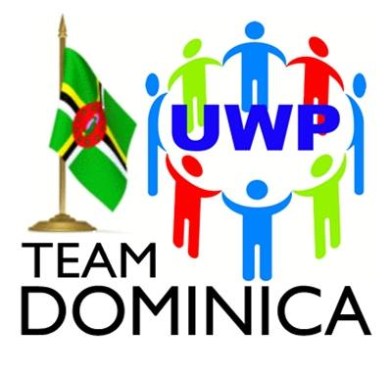
UNITED WORKERS PARTY
6 River Street, Roseau, Commonwealth of Dominica
Tel: (1) 767-265-0928 | (1) 767-3173-3014
uwpdaoffice@gmail.comwww.uwpteamdominica.com
President: Isaac Baptiste; Political Leader: Lennox Linton

Monday 9th August, 2021

PRESS RELEASE

UWP EMPHASIZES WITH CITIZENS AS COVID-19 CASES SPIKE

Roseau, Dominica Monday 9th August, 2021-The Executive of the United Workers Party (UWP)-TEAM Dominica empathizes with the Dominican citizenry as the Nation experiences a spike in Positive COVID-19 cases. The UWP specifically extends solidarity to the Front Line Workers who have been battling the COVID-19 surge currently being faced by Dominica. We express our heartfelt gratitude and appreciation to all Front Line Workers as they continue to devote time and energy to contain this pandemic. We will continue to offer our services as we have always done to help in your effort to mitigate the impact of unprecedented health emergency.
The UWP has been, from the onset, playing an active role in the fight to curb, then eradicate the threat of COVID-19 affecting the island through its mass education drives as well as delivery of supplies to the vulnerable during this crisis. The Party will continue to be proactive in its efforts as the fight continues.
Team Dominica yearns for better structure, discipline and organization in decision making and action being undertaken in dealing with the current surge. The Party wishes that the dissemination of information relative to the curbing of COVID-19 would be timelier to achieve successful implementation so as to muster greater cooperation from residents.
The United Workers Party once again places the expertise of its TEAM Members in crisis management, public health administration, logistics and public affairs communication, at the disposal of the Government in the National response to the COVID-19 pandemic.
The UWP encourages every Dominican to continue adhering to the COVID 19 Protocols issued by the Ministry of Health as well as obeying the Curfew Orders proclaimed by His Excellency the President of the Commonwealth of Dominica. END

